x = c(89, 177, 189, 354, 362, 442, 965)

y = c(.40, .60, .48, .66, .61, .69, .99)

# a)

plot(x, y)

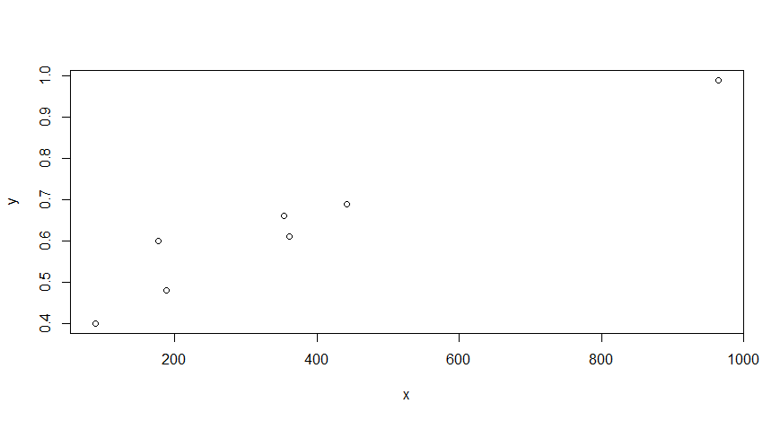

# b)

model = lm(y ~ x)

model$coefficients

# > model$coefficients

# (Intercept) x

# 0.4041237853 0.0006210758

# As the fluid flow velocity for a 5% soluble oil changed by 1 cm/sec,

# the extent of mist droplets will change by 0.0006210758 unit

# c)

summary(model)

# S_e = residual error = 0.05405

# The typical deviation of the extent of mist droplets about the fit

# is about 0.05405

# d)

beta_hat = model$coefficients[2]

df = length(x) - 2 # df = 5

t = 2.571 # From table IV

s_e = 0.05405

s_xx = sum((x - mean(x)) ^ 2)

c(beta_hat - t* s_e/sqrt(s_xx), beta_hat + t* s_e/sqrt(s_xx))

# CI at 95%: (0.0004261986, 0.0008159531)

# We are 95% confident to say that the true average change in mist

# associated with 1 cm/sec increase in velocity is between

# (0.0004261986, 0.0008159531).

# e)

x_1 = 250

y_hat = beta_hat * x_1 + model$coefficients[1]

df = length(x) - 2 # df = 5

t = 2.571 # From table IV

s_e = 0.05405

s_xx = sum((x - mean(x)) ^ 2)

c(y_hat - t * s_e * sqrt(1 / length(x) + (x_1 - mean(x)) / s_xx),

y_hat + t * s_e * sqrt(1 / length(x) + (x_1 - mean(x)) / s_xx))

# CI at 95%: (0.5069126, 0.6118729)

# We are 95% confident to say that the true value of the extent of mist droplets

# when the fluid velocity is at 250 m/sec is between (0.5069126, 0.6118729)

# d)

x_2 = 250

y_hat = beta_hat * x_1 + model$coefficients[1]

df = length(x) - 2 # df = 5

t = 2.571 # From table IV

s_e = 0.05405

s_yhat = s_e * sqrt(1 / length(x) + (x_2 - mean(x)) / s_xx)

c(y_hat - t * sqrt(s_yhat ^ 2 + s_e ^ 2), y_hat + t * sqrt(s_yhat ^ 2 + s_e ^ 2))

# PI at 95%: (0.4108506, 0.7079348)

# At 95% prediction level, plausible values for a single observation on the extent

# of mist droplets when the fluid velocity is at 250 m/sec, are between (0.4108506, 0.7079348)